**COMSAT UNIVERSITY ISLAMABAD ATTOCK CAMPUS**



**INFORMATION SECURITY**

**NAME: MENAHIL NOOR**

**REGISTRATION NO: SP24-BSE-035**

**ASSIGNMENT: 02**

**SUBMITTED TO: MA’AM AMBREEN GUL**

**DATE: 7 OCTOBER 2025**

**Graded Task 1:**

**You have implemented DES there is built in implemented DES in python in crypto cipher module use it for encryption/decryption and provide output sample example**

**CODE:**

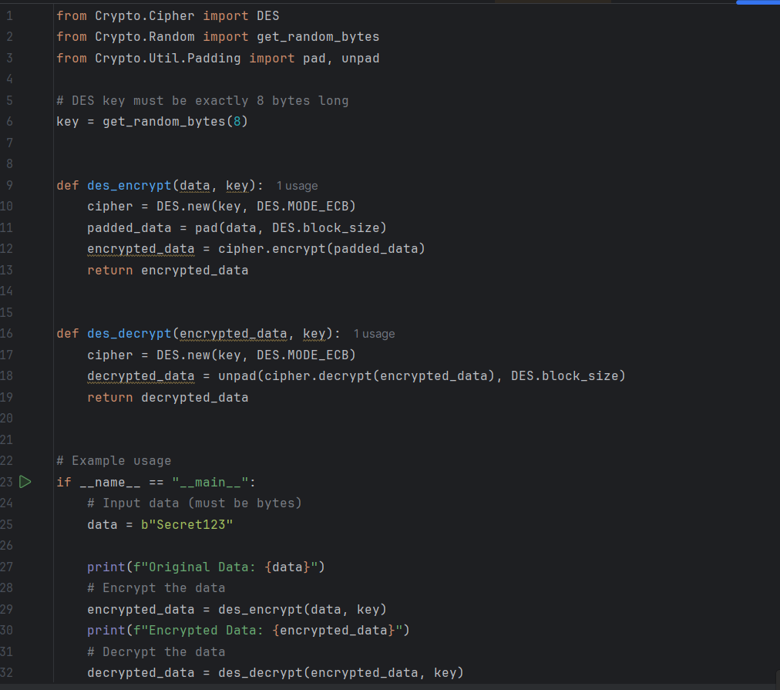

**OUTPUT:**

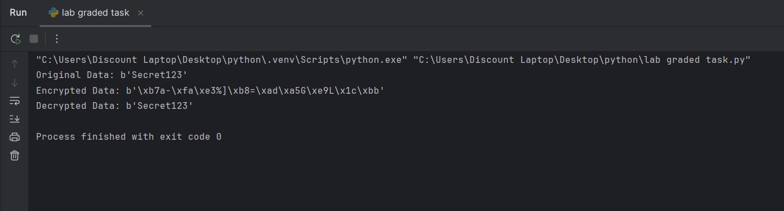

**Graded Task 2:**

**Visualization of MITM Attack Flow:**

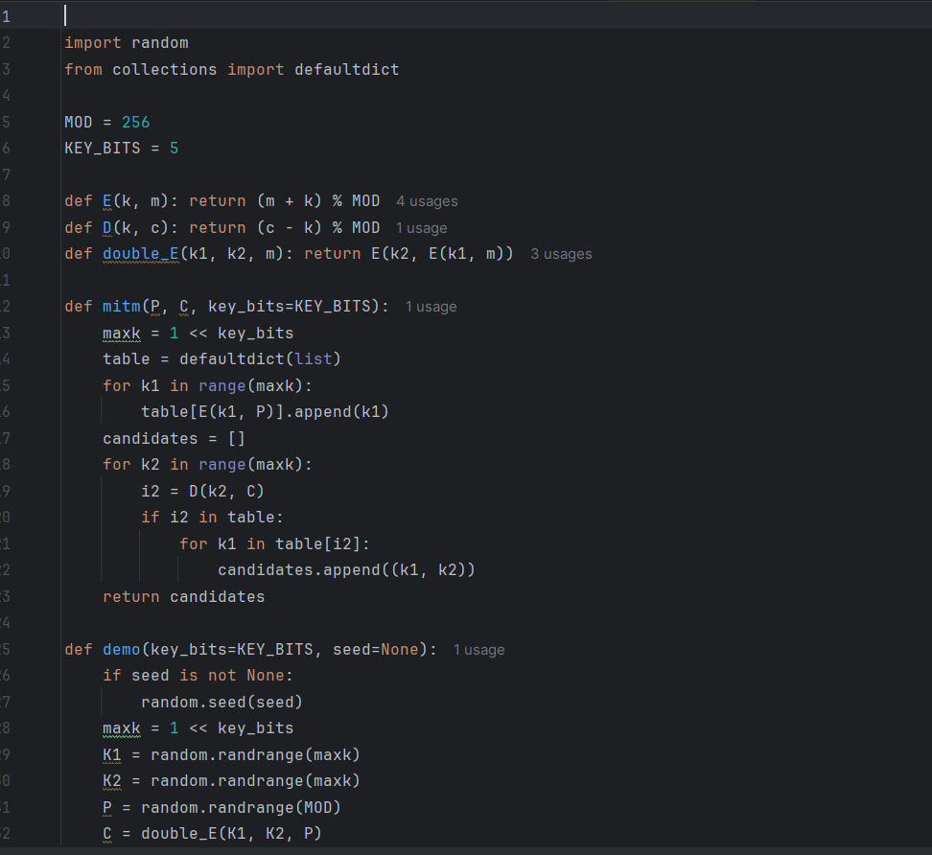**CODE:**

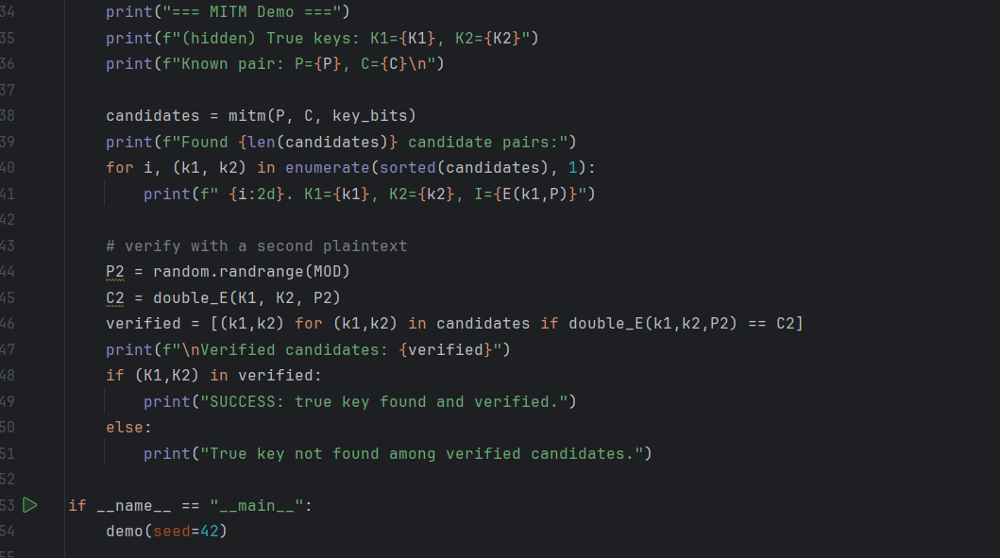

OUTPUT:

